***NANCY JULIANA LUNG’STO***

***BRENDA JEPKORIR LAGAT***

***Software Development of an Interactive Kiosk for a Science Museum to be used by children and its Mobile application.***

**INTRODUCTION**

Digital Pathways is developing an Interactive Kiosk for a Science Museum, designed specifically for children. Interactive games and educational activities with a wind turbine theme will be available at the kiosk. Through entertaining and engaging content, the objective is to inform and involve younger visitors while naturing their interest in renewable energy sources. The goal of this initiative is to give kids an enhanced museum experience by fusing technology and teaching.. With the use of a range of educational activities and interactive games, this cutting-edge kiosk will concentrate on offering a thorough understanding of wind turbines. Through the integration of interactive and engaging components with educational information, the kiosk seeks to pique young museum visitors' curiosity and cultivate a deeper interest in renewable energy. The project demonstrates Digital Pathways' dedication to developing engaging and instructive programs that use technology to make learning more accessible and pleasurable for kids.

**PROJECT REQUIREMENTS**

**The requirements needed throughout the project include the following ;**

1. Functional Requirements:

**Educational Content:**

Provides an explanation of wind turbines, covering their features, advantages, and design.  
 This enables improve comprehension, use visual aids like diagrams, movies, and animations.

**Interactive games:**

Provide entertaining activities that introduce kids to the principles of wind energy, like building turbines and producing electricity.  
 Include varying degrees of difficulty to accommodate different age groups.

**User Interface (UI):**

Design a child-friendly, intuitive, and visually appealing interface.

Ensure easy navigation with clear instructions and feedback.

**Accessibility:**

Ensure the kiosk is accessible to children with disabilities, including options for audio narration and adjustable text sizes.

1. Technical Requirements:

**Hardware:**

High-resolution touchscreen display .Robust and durable construction to withstand frequent use, and Integration of speakers for audio output.

**Software:**

Create the kiosk app on a scalable and reliable platform and also ensure that it works with the current IT setup at the museum.

**Content Management:**

Install a content management system (CMS) to make maintaining and updating instructional materials simple.

1. Non-Functional Requirements:

**Performance:**

Ensure that every interactive piece responds quickly to the system and the Software should be optimized to function well on the chosen hardware.

**Security :**

Implement security measures to protect the kiosk from unauthorized access and tampering.

**Usability:**

Test the usability of the UI and interactions with kids to make necessary improvements.  
Within the kiosk application, give users clear instructions and assistance.

1. Project Management Requirements

**Timeline:**

Define a project timeline with milestones for design, development, testing, and deployment.

**Budget:**

Allocate a budget for hardware, software development, content creation, and testing.

**Team:**

Assemble a multidisciplinary team including designers, developers, educators, and project managers.

**Stakeholder Involvement:**

Engage with museum staff and educators to ensure the kiosk meets educational goals and fits seamlessly into the museum environment.

1. Testing and Evaluation:

**User Testing:**

Conduct user testing sessions with children to gather feedback and make necessary adjustments.

**Performance Testing:**

Test the kiosk under various conditions to ensure reliability and performance.

**Evaluation:**

Implement a feedback mechanism within the kiosk to gather user input for future improvements.

**SEQUENCE DIAGRAM**

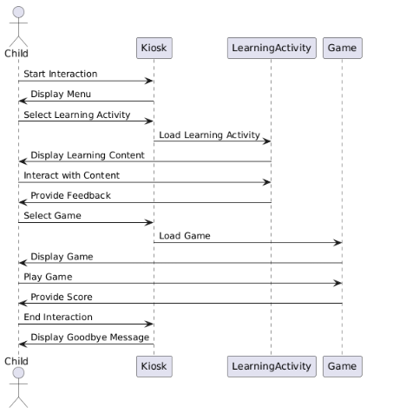

**Lessons Learnt during the software implementation**

**Effective Project Management**

The project management practices, including clear timelines, budgets, and communication plans, are vital for project success.

**Iterative Development and Testing**

Implementing iterative development and regular testing phases can significantly improve the final product that is trusted by the company and most importantly works efficiently.

**Early and Continuous Stakeholder Engagement**

Engaging stakeholders early and consistently throughout the project lifecycle is crucial and ensures that the project stayed aligned with the museum's educational goals and the needs of the children using the kiosk.

**Training and Support**

Providing adequate training for museum staff on the use and maintenance of the kiosk is essential for long-term success.

**Accessibility and Inclusivity**

Designing for accessibility ensures that the kiosk can be used by all children, including those with disabilities.

**Content Development and Adaptation**

Developing educational content that is both informative and engaging for children requires creativity and iterative refinement.

**Feedback and Continuous Improvement**

Collecting feedback from users and stakeholders after deployment is crucial for ongoing improvements thus enables future enhancements and ensured the kiosk continued to meet user needs.

**Documentation and Knowledge Transfer**

Thorough documentation of the development process, decisions made, and lessons learned is valuable for future projects.

**References**

1. **Google Firebase Documentation: https://www.python.org/doc/**
2. **Python Programming Language Documentation:https://www.python.org/doc/**
3. **GitHub Guides:https//:guides.github.com/**
4. **Usability Guidelines for children htttps://www.nngroup.com//articles/childrens-websites-usability-issues/**